## SHIMATSU HPLC - Check list before turning off

## Date:____/____/_____ (yyyy/mm/dd)

## After the completion of your method

* Stop the method
* Shut down the detector in the program (turn it off)
* Adjust the flow rate to 0 smoothly
* Open the PURGE switch

## Purge to the storage buffers

* Change buffer A to aqueous buffer
* Change buffer B to organic buffer

|  |  |  |  |
| --- | --- | --- | --- |
| Buffer | Component 1 | Component 2 | Filtered? |
| A | water | -- |  |
| B | 65% CH3CN |  |  |

* If you have programmed protocol, check this box and Skip the following steps
* Set B to 50%
* Adjust total flow to 2 ml/min

|  |  |  |  |  |  |  |
| --- | --- | --- | --- | --- | --- | --- |
| Rate(ml/min) | 0.2 | 0.5 | 0.7 | 1 | 1.5 | 2 |
| Check |  |  |  |  |  |  |

* Set the flow rate to 0

|  |  |  |  |  |  |  |
| --- | --- | --- | --- | --- | --- | --- |
| Rate(ml/min) | 1.5 | 1 | 0.7 | 0.5 | 0.2 | 0 |
| Check |  |  |  |  |  |  |

## Replace the buffer to storage condition in the column

* **storage condition:______________________________________________________**

**<65% CH3CN>**

* Make sure the pump is on
* Adjust the percentage of B (65% CH3CN) to 10% in pump page
* Turn the PURGE switch off
* Adjust the flow rate by following order

|  |  |  |  |  |  |  |
| --- | --- | --- | --- | --- | --- | --- |
| Rate(ml/min) | 0.2 | 0.5 | 0.7 | 1 | 1.2 | 1.5 |
| Check |  |  |  |  |  |  |

**Now we want to run the gradient to 100% B which will be 65% CH3CN**

* Increase the concentration of B by 10% every 2 min until 100% B reached.

|  |  |  |  |  |  |  |  |  |  |
| --- | --- | --- | --- | --- | --- | --- | --- | --- | --- |
| 10 | 20 | 30 | 40 | 50 | 60 | 70 | 80 | 90 | 100 |
|  |  |  |  |  |  |  |  |  |  |

* Slow the flow rate to 0

|  |  |  |  |  |  |  |  |
| --- | --- | --- | --- | --- | --- | --- | --- |
| Rate(ml/min) | 1.5 | 1.2 | 1 | 0.7 | 0.5 | 0.2 | 0 |
| Check |  |  |  |  |  |  |  |

* 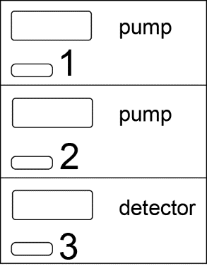Turn off the program
* Turn off the machine by the order 🡪 3🡪2🡪1

## Comments: